**===========================Authorized Only=========================**

*The following content is accessible only to:*

* *Members of the O5 Council*
* *Authorized Personnel, and;*
* *PSI-4 authorized personnel with Level 4 or higher clearance*

*If you do not belong to one of the aforementioned groups, please stop reading immediately and remain in position. Delta-083 “Margaret Atwood” has been dispatched to your location.*

*A memetic kill agent is attached in this document. Immediate cardiac arrest will be caused in any unvaccinated personnel. Scroll down to proceed.*

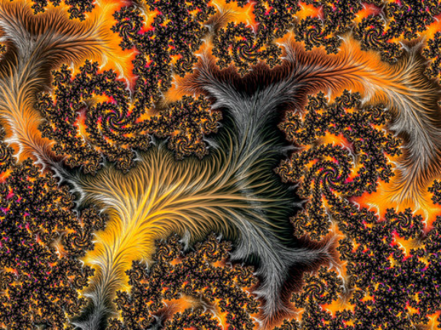

Agent active. Vital signs normal. Welcome, authorized personnel.[1]

**Item #:** SCP-CA-001

**Object Class:** ~~Keter~~ Thaumiel[2]

**Special Containment Procedure:** SCP-CA-001-1 (referred to as CA-001-1 below) is to be contained within the vicinity of ███████ School, Rothesay, New Brunswick. More than two (2) agents are to remain within ███████ School at all times to monitor the activities of CA-001-1. CA-001-1 is to be given relative bodily freedom and class 1.02 internet access. CA-001-1 is to be designated the head of the social sciences department at ███████ School indefinitely, and is allowed to teach up to eighty-three (83) students simultaneously. CA-001-1 is an alumnus of St. Thomas University in the class of 1986 as a coverup story. Should suspicion arise within the public, Delta-083 *“Margaret Atwood”* is to relocate CA-001-1 temporarily and administer Class-A amnestic. Additionally, the nearest site (currently site-CA-039) is to have three (3) tactical nuclear warhead aimed at ███████ School until further instruction is given from the O5 Council.

SCP-CA-001-2 (referred to as CA-001-2) is to be contained within a standard containment safe within site-CA-039, ~~printed copies of activated CA-001-2 is to be mass distributed to students by CA-001-1 as a form of “reward” in order to mitigate its effects~~ printing new copies of activated CA-001-2 is strictly prohibited.

Update on December 25th, 2021: Protocol Damocles is to override all existing Special Containment Procedures once in effect. See addendum for the contents of Protocol Damocles.

**Description:** SCP-CA-001 is a relationship between CA-001-1 and CA-001-2. CA-001-1 is a male humanoid entity, appearing to be of Irish descent and around 60 years of age, with the preferred name [Redacted] “Charlie” [Redacted]. CA-001-1 is observed most commonly in a striped shirt and tie, brown business pants, and a black belt. CA-001-1 appears to possess extensive knowledge of world history, geography, and relevant social science subjects, but poor understanding of humour and physical sciences. CA-001-1 is keen to share its knowledge with individuals below the age of 20, displaying proficiency in education and discipline. When human test subjects of any age remain within 3-meter radius of CA-001-1, an increase in productivity is reported, as subjects find it easier to comprehend reading materials and produce writing. Establishing communication with CA-001-1 regarding history or geography allows the subject to gain temporary understanding of knowledge they have not been educated of (see interview records), however, such understandings diminish as subjects stop communicating with CA-001-1. Such knowledge cannot be transcribed by subjects due to the abstract nature of the knowledge. CA-001-1 possess the ability to produce copies of activated CA-001-2 at will.

CA-001-2 is a single card paper, with length 30 centimeters and width 5 centimeters, and the appearance of a poorly-edited version of a standard 1990 U.S. one dollar bill. However, instead of the picture of George Washington, a coloured photo of CA-001-1 is found at the centre of the bill; instead of 1 dollar, the value of the bill is 200 dollars; instead of The United States of America, the bill has printed “Chuck’s Bucks”, and; instead of “In God We Trust”, the bill has printed ███████. The original copy of CA-001-2 will materialize within a 30km proximity of CA-001-1 once it leaves said proximity, and cannot be activated. Copies of CA-001-2 can be activated once CA-001-1 has signed its name, a date, and a recipient on one side of the bill. Once activated, CA-001-2 cannot be deactivated. Printed copies of the activated CA-001-2 prove to not pertain the anomalous properties of CA-001-2. Copies of CA-001-2 does not possess anomalous properties if it is not possessed by the intended recipient denoted by the signature of CA-001-1. Once a copy is possessed by its intended recipient, it is considered to be “in circulation”. If the recipient, in possession of a copy of CA-001-2 in circulation, approaches CA-001-1, and asks to “buy some time”, CA-001-1 will offer the time as “for here” or “to go”. If the subject replies “for here”, they will be transported to a set moment in time before the conversation, with only themselves and CA-001-1 retaining the memory of the time period; if the subject replies ‘to go”, they will be transported to a set moment in time after the conversation, without the memory of the time period that passed and the biological age unchanged. Currently, said set period of time is exactly 180 days (4,320 hours, or 15,552,000 seconds). After the transportation, the copy of CA-001-2 will vanish with no exceptions, hence it will be considered to be “out of circulation”. CA-001-2 is subject to inflation. That is, the total number of CA-001-2 in circulation and the number of printed, activated copies of CA-001-2 (referred to as the inflation factor of CA-001-2) defines the amount of time “purchasable” by one copy of CA-001-2 in circulation. Interview with CA-001-1 shows that the original value of one copy of CA-001-2 in circulation is two hundred thousand (200,000) years.

Update on December 1st, 2005: Interview with CA-001-1 shows that if the inflation factor of CA-001-2 exceeds the number of humans on Earth, a ZK-class reality failure will ensue. ~~Pending instructions from the O5 Council.~~

**History:** CA-001-1 was found on campus in ███████ School on September 1990, as reports of his anomalous properties were submitted to the local RCMP stations. MTF Delta-083 immediately contained CA-001-1 within a standard humanoid containment cell on site-CA-039. The original copy of CA-001-2 was subsequently obtained one month later as it rematerialized within a classroom of ███████ School, and was contained. Witnesses and relevant POIs were interviewed and given class C amnestic before released. After several rounds of interview, the O5 council voted 6-5 in favour of a release of CA-001-1, under the condition that he will remain on good terms with the foundation and class-A amnestic were given regarding secretive informations of the foundation.

**Addendum 1:** Experimentation with CA-001-1 and CA-001-2

Date: 12/12/1990

Test Subject: D-2048

Foreword: D-2048 was instructed to approach CA-001-1 with a CA-001-2 in circulation while wearing a recording device and communication device. Dr. Steven Li is supervising.

<Begin Log>

Dr. Li: D-2048, can you hear me clearly?

D-2048: Yes. This device working pretty damn well. There was someone staring at me down the hallway when I got here, pretty unnerving.

Dr. Li: Don’t worry about that. Walk into the classroom. Please don’t say anything out of terms, remember your protocol with the foundation.

D-2048: Alright, aright.

[D-2048 takes a deep breath and walks into the classroom of CA-001-1]

CA-001-1: Hello. Are you on tour here? It’s not a dress down today, so-

D-2048: I would like to buy some time.

[CA-001-1 seems surprised for a moment, then regains composure]

CA-001-1: Sure. The rate now is one for 12 months. For here or to go?

Dr. Li: Ask him about 001-2.

[D-2048 pulls out CA-001-2 and hands it to CA-001-1]

D-2048: Is this the right thing to use here? Not regular money?

[CA-001-1 examines the bill]

CA-001-1: Yes, it is. I’m afraid you have to hurry; I have a class coming in here soon.

D-2048: Okay. Let’s see…

Dr. Li: Say “to go”.

D-2048: I’ll get one to go.

CA-001-1: Right away.

[CA-001-1 and CA-002-2 vanishes. The connection between D-2048 and Dr. Li breaks, and the camera records a split moment of pitch darkness before resuming to the classroom.]

D-2048: Wha-

[D-2048 is apprehended by Delta-083 *“Margaret Atwood”*]

<End Log>

Closing Statement: D-2048 disappeared immediately following his confirmation, as he was transported to exactly 12 months in the future. The school was closed on that day, and MTF Delta-083 easily recollected D-2048. Efforts to recollect the instance of used CA-002-2 proves to be futile. Physical examination of D-2048 proves that he has not aged through the 12 months of time. The file of SCP-CA-001 was edited, and Dr. Li submitted proposal for further experimentation.

**Addendum 2:** Experimentation with CA-001-1 and CA-001-2

Date: 01/05/1991

Test Subject: Researcher Wilson

Foreword: Dr. Steven Li supervises this experiment. The goal of this experiment is to discover the purpose of the “for here” option when purchasing time with CA-001-1. Researcher Wilson has been working consistently for the foundation for the past 3 years, and was instructed to remain in hiding until he reaches the chronological time of the experiment, should he be transported back in time after or due to the experiment, in order to minimize his impact on the causal reality. It is worth noting that the inflation factor has increased by 730 since the last experiment.

<Begin Log>

Researcher Wilson: Can you hear me doctor?

Dr. Li: Yes, researcher. Good luck.

Researcher Wilson: Perfect.

[Wilson walks into the classroom of CA-001-1]

CA-001-1: Hello.

Researcher Wilson: I would like to buy some time.

CA-001-1: Sure. The rate now is one for 8 months. For here or to go?

[Wilson takes a deep breath and gives CA-001-1 the CA-001-2 in circulation]

Researcher Wilson: For here, please.

CA-001-1: Right away.

[CA-001-1 and CA-001-2 disappears. The connection between Wilson and Dr. Li breaks, and the camera records a split moment of pitch darkness before resuming to the classroom.]

Researcher Wilson: Doctor? Can you still hear me?

[Around ten seconds of silence. Researcher Wilson checks his watch.]

Researcher Wilson: Hot damn.

[Researcher Wilson runs outside the classroom.]

<End Log>

Closing Statements: Researcher Wilson was transported to exactly 8 months before the interaction. He remained hidden in a nearby foundation-owned apartment for 8 months until returning on site, right after he was reported to have departed for the interaction. Biological examination of Wilson shows that he has aged 8 more months.

**Addendum 3:** Protocol Damocles

Honourable Members of the Council:

It is my pleasure to introduce to you Protocol Damocles, the first comprehensive system in which the foundation can mitigate dangers of any adversity. Due to the anomalous nature of SCP-CA-001-1 and CA-001-2, cooperation has been established between the foundation and CA-001-1 in order to further protect the integrity of the human race in face of any danger. In face of any end-of-the-world scenario, all CA-001-2 instances is to be submitted to CA-001-1 in order to travel negatively in time and prevent said scenario from taking place. Currently, the foundation has, in possession, 30 copies of CA-001-2, allowing for 15 years of time. If the inflation factor is controlled, said 15 years would be the sword of Damocles for any adversities that exists in the future, or any hazard against humanity. I have attached the specifics of the plan, as well as the document of SCP-CA-001 with this letter.

Thank you for your consideration,

Doctor Steven Li.

Council Vote

7 In favour – 6 Against

**Passes**

O5-3: Protocol Damocles is revised by the council. See attached.

Attachments:

[Error 403 – Not Enough Clearance].

[Error 403 – Not Enough Clearance].

**Addendum 4:** Record

Foreword: On Jan 5th, 2022, site-083 received this recording in an encoded foundation communication channel. Memetic examination indicates that there are no memetic hazards within the recording. However, the metadata of the recording, as well as the information listed on the channel both indicate that it was recorded on Jan 10th, 2032, 10 years in the future.

<Audio Starts>

Male voice: Hello, whoever is listening. This is Researcher ██████[3] from the Canadian branch, or what’s left of it. Anyways, 001-1 is not trustworthy. Protocol Damocles basically screwed us all over. Reality is literally breaking into a blackhole the first moment we met our colleagues in the past, and this-

[Gun shots, giant noise in the distance caused by presumably a collapsing structure]

Male voice: This giant fucking green shirted man just walks out of it. He’s- He almost looks like that Sheldon Cooper dude from the last century show. The foundation is ruined. Half of Canada is baked or eaten by the giant reality blackhole thing. The Canadian and American branch is gone, European branch is still alive, but sabotaged by The Serpent’s Hand. The Chinese branch is still fighting but I doubt-

[Machine gun shoots in the distance, some people yelling, subsequent heavy stomping in the distance]

Male voice: Look, I don’t have much time. I’m probably gonna be dead very soon. Get rid of that Damocles bullshit as soon as possible, it’s not helpful, removing it is the only way to save us all. Maybe something will collapse causally but at this point-

[Something explodes near the recording device, resulting in 5 seconds of prolonged ringing]

Male voice: [Yelling] Shut up! I’m sending it!

<Audio Ends>

Closing Statements: After requested urgently by site director, Protocol of Damocles is currently being revised by the O5 Council, and a vote is in process to reclassify SCP-CA-001 to Keter.

**Addendum 5**: Relevant photos

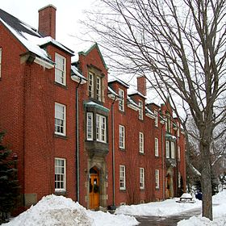5-1.

A building in ██████ School

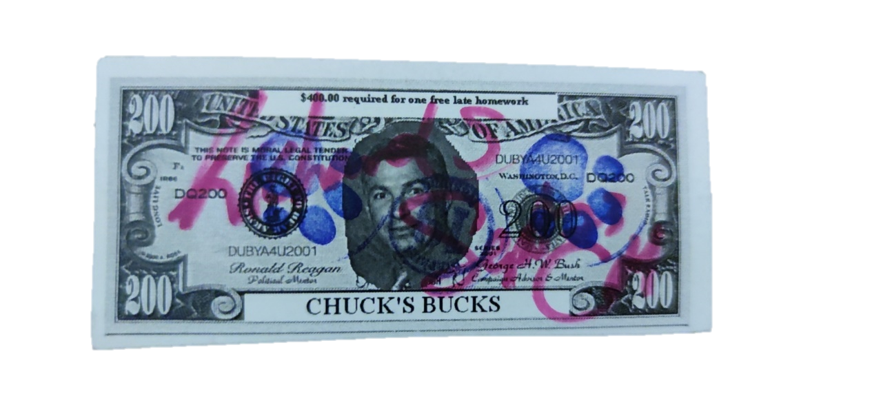5-2.

Uncoloured, activated copy of CA-101-2, recipient is ███████ Su, a student of CA-101-1

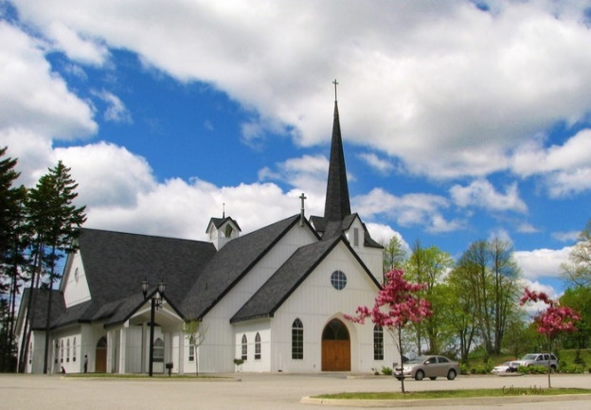5-3.

Site-CA-039, disguised as a local church. Main site facilities are underground.

1. Thank you to Mr. Charles McEvoy for “allowing” me to use him as an SCP. You’re a wonderful teacher.
2. Pending reclassification to Keter, Council voting in process – Jan. 7th, 2022

  
3. The name was unrecognizable in the original recording, presumably intentionally blurred to avoid a ZK class scenario.